Chapter 9, Solution 70.

Make a delta-to-wye transformation as shown in the figure below.
c

b
n

a

Z_{an}

Z_{cn}

Z_{bn}

2 
8 
-j5 
Z_{eq}
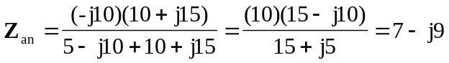
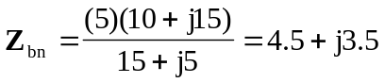
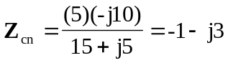

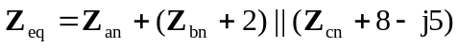
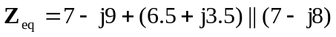
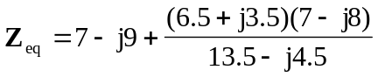
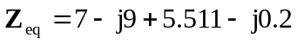
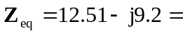 15.53-36.33 

